# Event Manager Android App

The event manager android app is a tool for acquiring events and appointments from a remote web service. The events acquired from the web service are filtered based on schedule relevance and added to the phones calendar. Expired events are ignored. The app main view will display the current day’s events with Title, Agenda and Time.

The app features are described in the following screenshots. These screen shots are taken on the android 4.1 Google API emulator.

1. The empty list with no current day events or appointments:  
   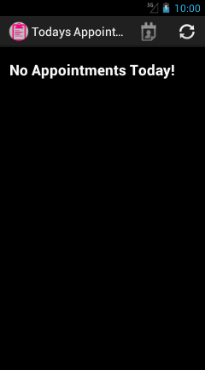
2. Display when ‘menu’ button is pressed. Here there are 3 menu items but 2 of the menu items are directly displayed in the Title bar of the app. This is a feature of Android 4.1 jellybean. In the older version like Froyo all items will be displayed in the Menu itself.  
   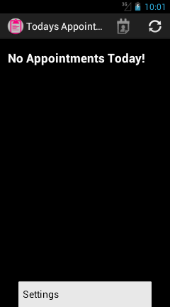
3. The “Settings” Screen is used to set user preferences  
     
   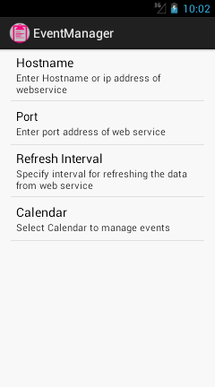
4. The Calendar preference lists the available calendars in the phone. By default the first calendar is always taken. If no calendars are available this option will be grayed. All stock phones have at least one calendar.  
     
   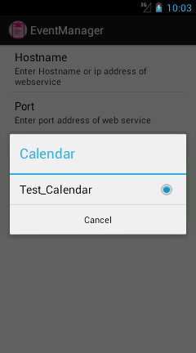
5. The other preferences are:
   1. Hostname: This allows user to add a hostname or IP address of the remote service
   2. Port: This allows user to specify the port address of remote service.
   3. Refresh Interval: specifies the refresh interval via which the app service will periodically query the web service for new events. By default this value is set to a day interval.

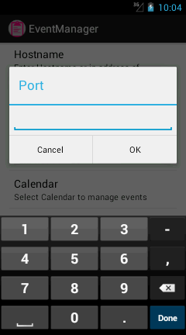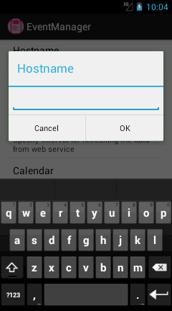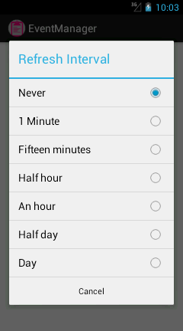

1. 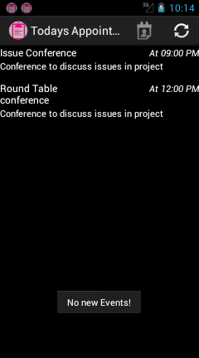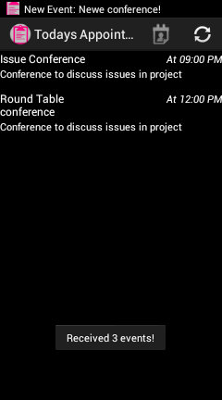Refresh Button when clicked will query the Web service on the fly and and will update the list with current days events if any, send notifications for all new events received and display a toast message indicating number of new events received. If app is not visible than only notifications for received events will be shown. If no new events are retrieved than toast message will show “No new Events!” message if view is visible.
2. The notification screen will display new events received and clicking on the event title will take the user to the event view screen where the user can add more reminders, delete the event if not interested   
   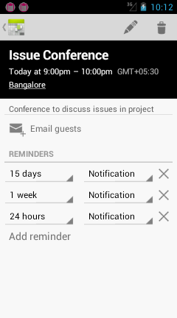

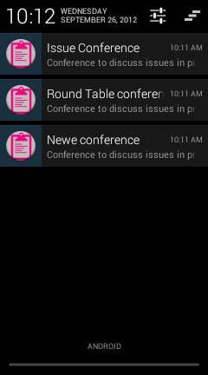

1. Clicking on the calendar button will display the calendar widget for the current day  
   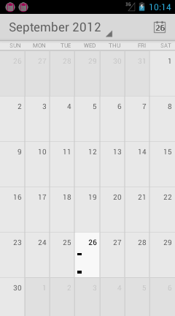
2. If there is no network connection and user presses the refresh button on the app than following error message is displayed:

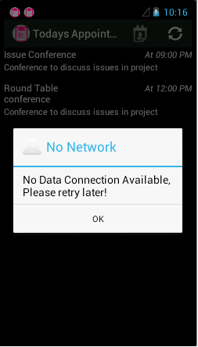

1. The test web site for the data displayed in the app is as follows:

